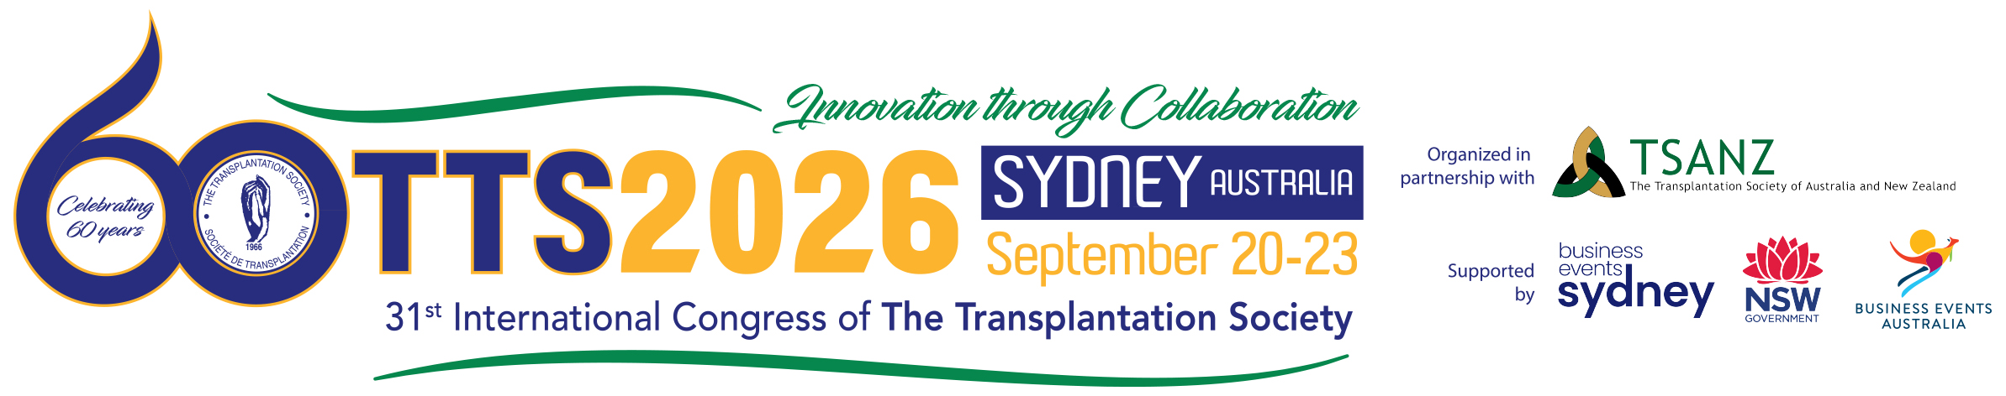
Letter to Manager/Supervisor
(Date)

Dear (Manager/Supervisor Name),

After reviewing the program and activities, I am interested in attending the 31st International Congress of the Transplantation Society, to be held in Sydney, Australia from September 20th- 23rd, 2026. I have submitted an abstract to the meeting and look forward to presenting my work to an international audience.

The Congress will enable me to attend a number of technical sessions that are directly applicable to my work, such as: (list names of 4-5 sessions). Many of the presentations are tailored to (enter your field here) and give information on how to (list benefits to your responsibilities). These sessions offer the unique opportunity for me to learn from thought leaders and experts in the field of transplantation. The Congress will also be a prime location to network with a variety of academic and industry leaders from around the world.

Therefore, I am seeking sponsorship of the registration fee and travel-related expenses during the Congress. A detailed cost breakdown is here below.

The full-price conference fee is ($), if registered before June 23, 2026. The registration includes access to all sessions, exhibit area, materials, WiFi, welcome reception and food and beverage offered onsite (coffee breaks and lunches).

The cost breakdown is as follows:
- Roundtrip airfare:
- Transportation:
- Accommodations:
- Meals:
- Conference Add-ons: (ticketed events)

The total cost associated with attending is:

I will be applying for external grants to help support my attendance, including the TTS Mentee-Mentor award and hope that these will help to subsidize the costs of attendance. I look forward to hearing from you.

Sincerely,

