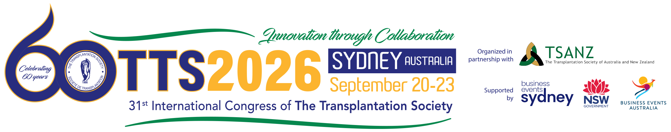

Expenses Worksheet
Use the worksheet below to develop a cost estimate for attending TTS 2026.

Expense | Guideline | Cost
Registration | Early-bird Registration – June 23, 2026 | $330
Additional Ticketed Events | Women in Transplantation Event ($0), Early Career Professional Networking Event $55), Congress Dinner ($55), Lunch & Learn Sessions ($25) | TBD
Lodging | Hotels in double occupancy are available as low as 229 AUD (~150 USD) a night. See website for details. | Accommodation
Flight | Qantas is the official congress airline partner.  Domestic travelers: 10% discount on listed airfare  International travelers: 5% discount on listed airfare  Code will be available with the registration confirmation.
Ground Transportation | Taxi, rental, public system including airport bus, and metro
Food & Beverage Per Diem | General Congress registration includes daily coffee breaks, lunch and welcome reception.  Expenses to include in your expense worksheet:  Breakfasts and dinners  Travel meals | TBD

