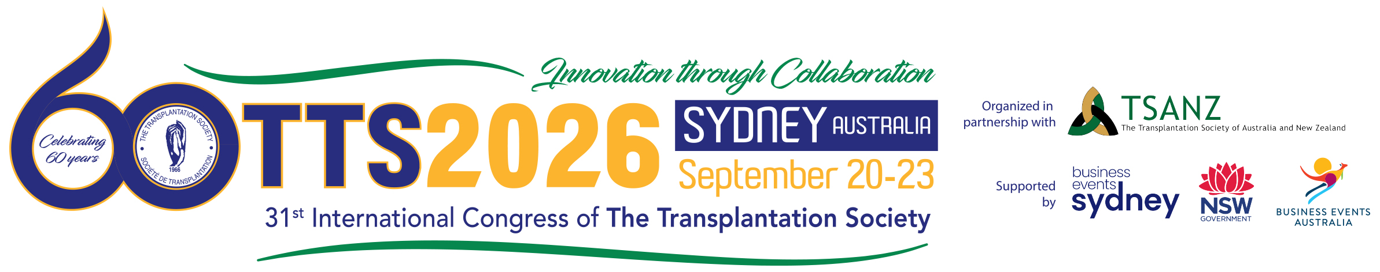
Congress Follow-Up Report
Executive Summary:

On September 20-23, (organization name) was represented at the 31st International Congress of The Transplantation Society in Sydney, Australia. The purpose of attending was to:

- Identify solutions to the problems our department faces today or may face in the future
- Find new ways we can better perform at better cost-efficiency over time
- Keep our finger on the pulse of the industry so that we know where it is going and how these changes will affect (organization name)
- Fulfill continuing educational requirements to maintain my certification, and;
- Establish contacts at other companies, universities, regulatory agencies, vendors and delegates that can help us continue to deliver high performance.

Solutions:

A number of items have been identified to be of beneficial impact to our organization which are described as follows:

Existing Process Improvements: (issues we are currently struggling with)

Leading Edge Concerns: (new rule changes that are about to be implemented)

Networking Takeaways: (new contacts, why they are important for the department, who will follow-up and when)

Trade Show Exhibit Takeaways: (information gathered from the Exhibit area about products and services of interest)

Program Ideas or Recommendations Inspired from the Congress: (what process or innovation is your organization currently doing that could be showcased at a future TTS event, who will prepare and submit an abstract to cover this topic from your organization)

Action items: (who will do what and when; dissemination plan for briefing staff on information gathered, timeline for planning for the next TTS Congress)

Conclusions and Recommendations: (Comment on the overall cost-effectiveness of the TTS 2026 experience. Would you recommend continued attendance from your organization?)
1

